## The Basic HTTP GET/response interaction

1. Is your browser running HTTP version 1.0 or 1.1? What version of HTTP is the

server running?

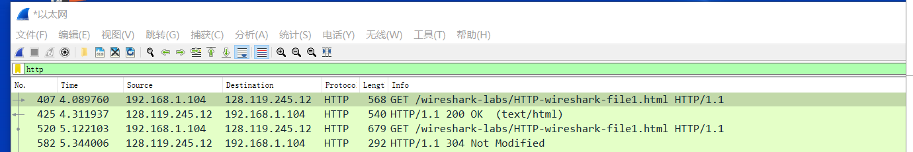

我的浏览器是http1.1，服务器也是http1.1

2. What languages (if any) does your browser indicate that it can accept to the

server?

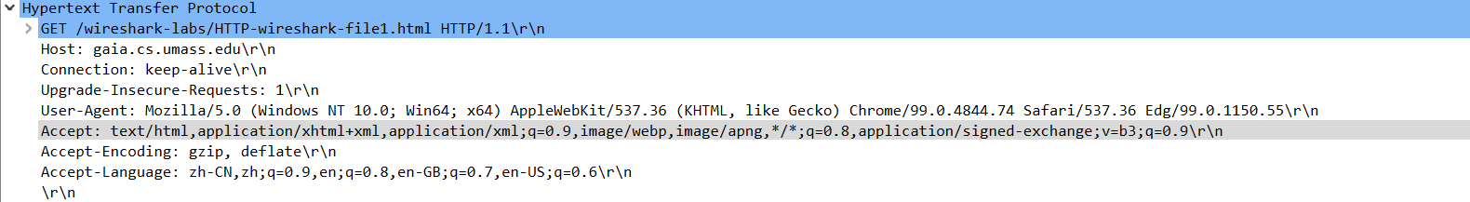

支持中文和各种英语

3. What is the IP address of your computer? Of the gaia.cs.umass.edu server?



我的ip是192.168.1.104，服务器的ip是128.119.245.12

4. What is the status code returned from the server to your browser?

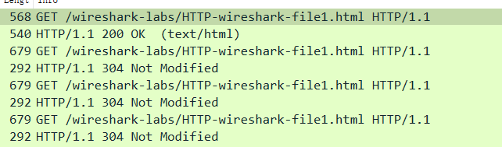

200和304

5. When was the HTML file that you are retrieving last modified at the server?

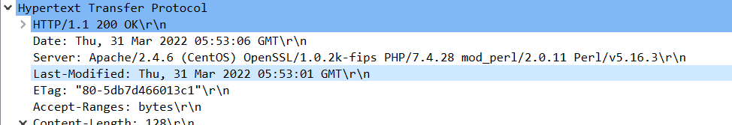

2022年 3月 31日 星期四 5：53：1 格林威治标准时间

6. How many bytes of content are being returned to your browser?

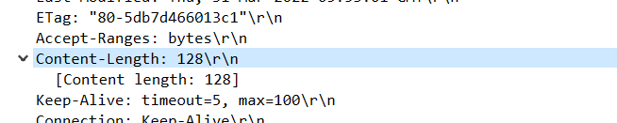

128bytes

7. By inspecting the raw data in the packet content window, do you see any headers

within the data that are not displayed in the packet-listing window? If so, name

one

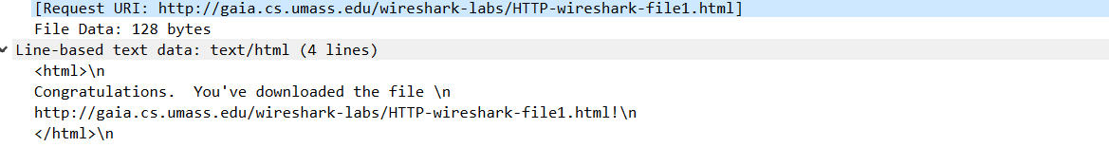 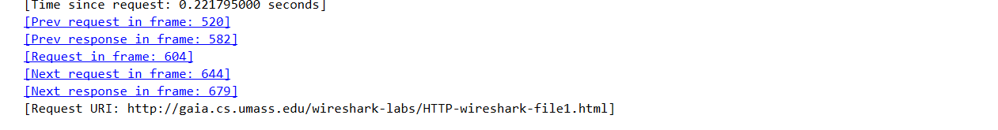

## The HTTP CONDITIONAL GET/response interaction

8. Inspect the contents of the first HTTP GET request from your browser to the server. Do you see an “IF-MODIFIED-SINCE” line in the HTTP GET?

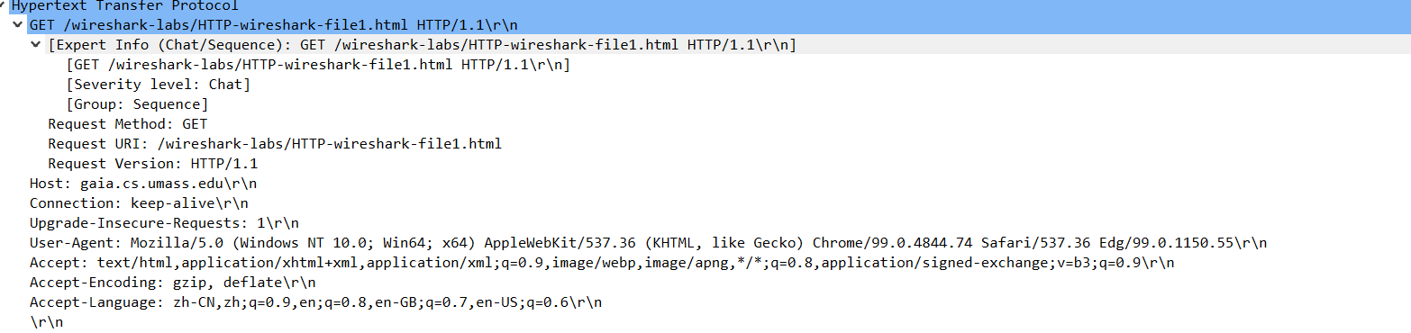

没找到“IF-MODIFIED-SINCE”

9. Inspect the contents of the server response. Did the server explicitly return the contents of the file? How can you tell?

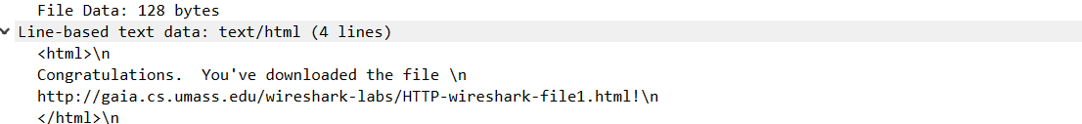

显示了，能读懂

10. Now inspect the contents of the second HTTP GET request from your browser to the server. Do you see an “IF-MODIFIED-SINCE:” line in the HTTP GET? If so, what information follows the “IF-MODIFIED-SINCE:” header?

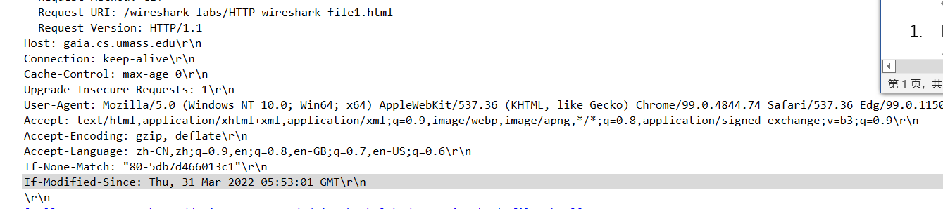

看到了，后面是时间的信息，和之前get得到的报文last-modified一样

11. What is the HTTP status code and phrase returned from the server in response to this second HTTP GET? Did the server explicitly return the contents of the file? Explain

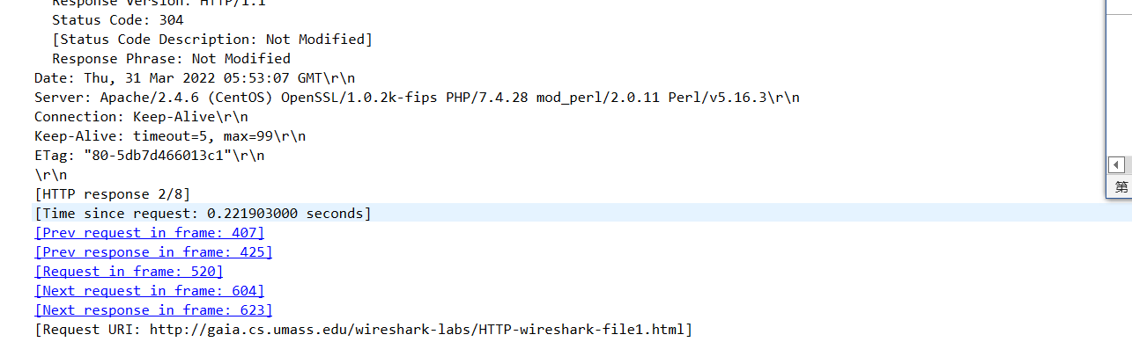

这次未返回文件的具体内容。因为第二次访问时系统中有缓存，直接采用的缓存文件。

1. Retrieving Long Documents

12. How many HTTP GET request messages did your browser send? Which packet number in the trace contains the GET message for the Bill or Rights?

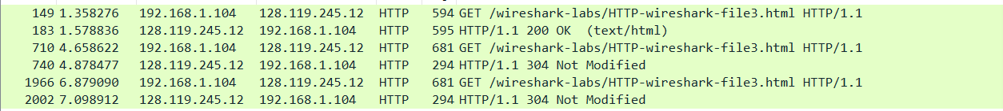

发送了三次，183号有数据

13. Which packet number in the trace contains the status code and phrase associated with the response to the HTTP GET request?



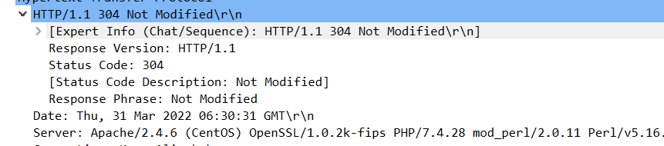

14. What is the status code and phrase in the response?

200 OK和304 NｏｔModified

15. How many data-containing TCP segments were needed to carry the single HTTP response and the text of the Bill of Rights?

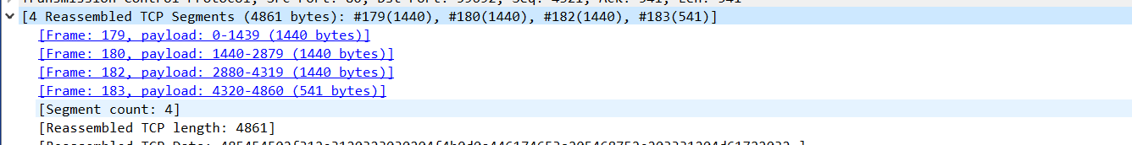

共需要四个ｔｃｐｓｅｇｍｅｎｔ